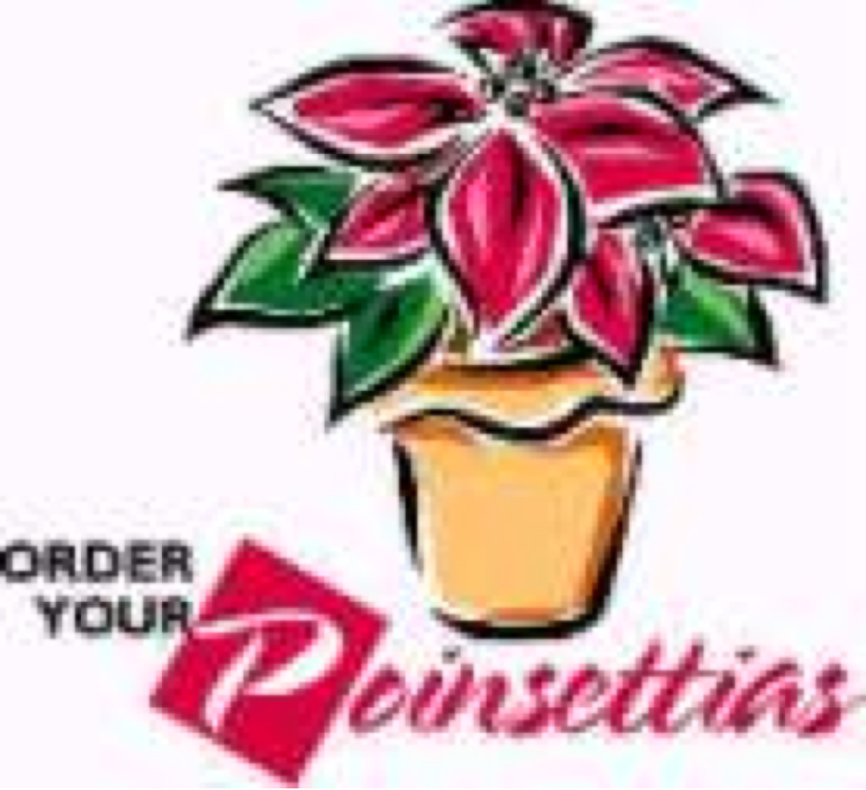

Children’s Board of Oswego, NY Inc.

Poinsettia Sale

Pre-order deadline is Tuesday, November 14th
We Will Deliver or You Can Pick Up at the Oswego Elks Club
On Friday, December 1st
10am to 2pm

Medium Plants are $13.00
Large Plants are $22.00
This year plants are available in Red or Pink

The Children’s Board of Oswego NY, Inc.
is a not-for-profit civic organization that provides free
programs, performances, and services
to children and families in Oswego County.
---------------------------------------------------------------------------------

to place your order contact the following member:

Contact Children Board member: ___________________________

OR

email:

call:

Thank you for your support

To learn more about the Oswego Children’s Board or to become a member
Visit us on Facebook at Children’s Board of Oswego, NY
or email oswegochildrensboard@gmail.com

