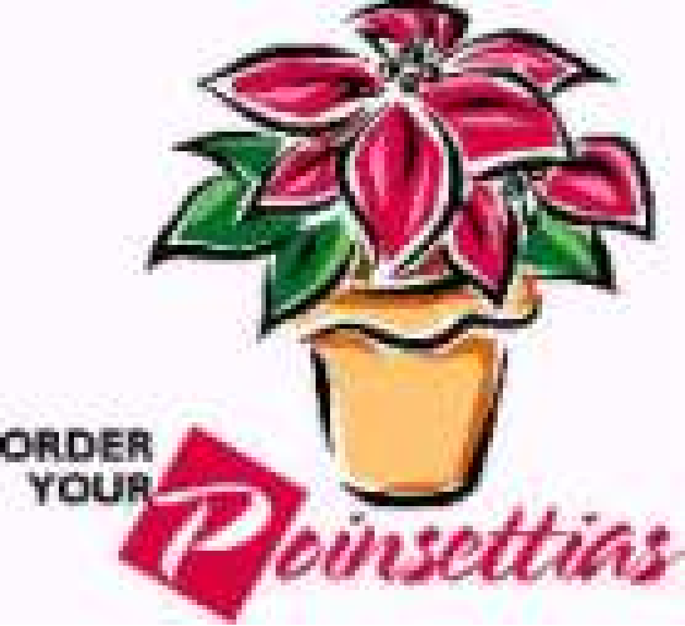

Children’s Board of Oswego, NY Inc.

# **Poinsettia Sale**

**Pre-order deadline is Tuesday, November 19th**

**We Will Deliver or You Can Pick Up at the Oswego Elks Club**

**On Friday, December 6th**

**10am to1:00pm**

**Medium Plants are $13.00**

**Large Plants are $22.00**

**This year plants are available in Red or Pink**

The Children’s Board of Oswego NY, Inc.

is a not-for-profit civic organization that provides free

programs, performances, and services

to children and families in Oswego County.

---------------------------------------------------------------------------------

**to place your order contact the following member:**

**Contact Children’s Board member: ___________________________**

**OR**

**email: Mary.bucher1@gmail.com**

Thank you for your support

*To learn more about the Oswego Children’s Board or to become a member*

*us on* ***Facebook*** *at Children’s Board of Oswego, NY*

*or* ***email***[*oswegochildrensboard@gmail.com*](mailto:oswegochildrensboard@gmail.com)